Power of Reading Curriculum Map Overview 2020-2021
 | Autumn 1 | Autumn 2 | Spring 1 | Spring 2 |  | Summer 1 | Summer 2
Year 1 | Harry and the Bucketful of Dinosaurs  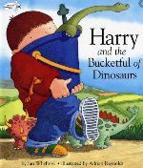 | 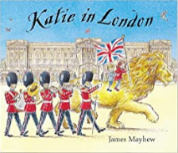  Katie in London | 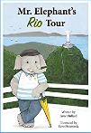  Mr Elephant’s Rio Tour | Man on the Moon  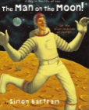 |  | Out and About  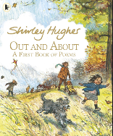 | One Day on our Blue Planet  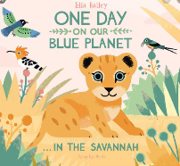
Writing Focus | Narrative | Information poster  Letter writing | Non-chronological report (Brazil) | Narrative  Description  Postcard |  | Poetry | Non-chronological report
Year 2 | The Bee who spoke  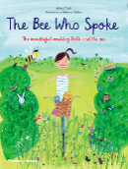 | The Magic Finger  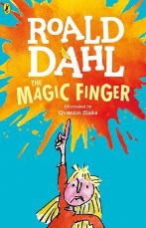 | Harry and the Jaggedy Daggers  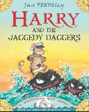  How to find Gold  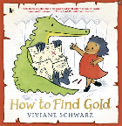 | Pattan’s pumpkin  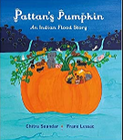  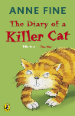  The diary of a killer cat |  | The dark  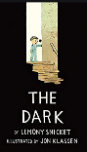  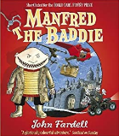  Manfred the Baddie | 10 things I can do to help my world  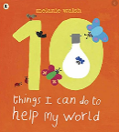  Out and About  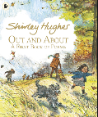
Writing Focus | Description  Instructions(flapjacks)  Non-chronological report (bees) | Persuasive letter  Diary entry | Character description  Newspaper report  Adventure story | Narrative  Poetry  Non-chronological report (India) |  | Instructions  Narrative  Recount (Castle trip)  Non-chronological report (bats) | Formal letter  Discussion/argument  Poetry
Year 3 | Ironman  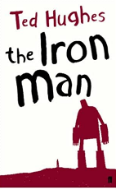 | 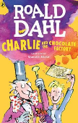  Charlie and the Chocolate Factory | Escape from Pompeii  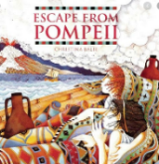  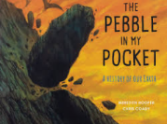  The Pebble in my Pocket | How to train your dragon  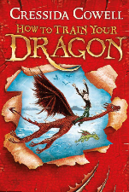 |  | Stone Age Boy  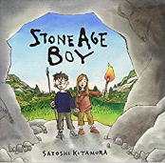  UG: Boy Genius of the Stone Age  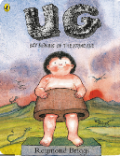 | Voices in the Park  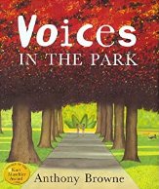  The boy at the back of the class  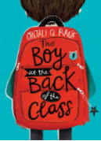
Writing Focus | Newspaper report  Adventure Narrative | Instructional writing  Biography  Poetry | Setting description  Narrative  Play script | Letter writing  Non-chronological report |  | Letter writing  Explanation text  Persuasive writing | Diary entry  Narrative
Year 4 | The Legend of  Romulus and  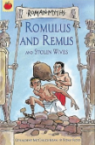  Remus  What the Romans have done for us | Demon Dentist  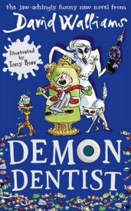 | The Lost Happy Endings  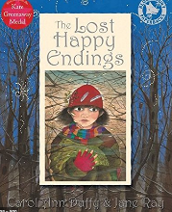 | Leon and the place between  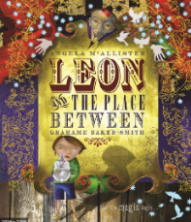 |  | 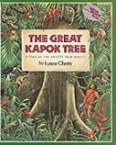  The Great Kapok Tree  Native American  Animal Creation  myths | Arthur and  the Golden Rope  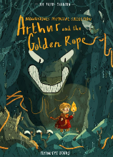
Writing Focus | Play script  Non-chronological report (Romans)  Instructions (Roman Soup) | Fact file  Narrative | Newspaper Report  Description | Letter Writing  Diary entry |  | Balanced Argument/debate  Myth | Leaflet  Advertisement
Year 5 | 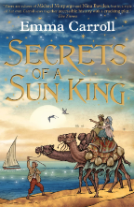  Secrets of a Sun King  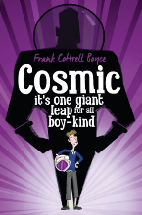  Cosmic |  | 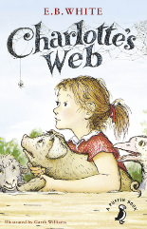  Charlotte’s Web  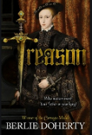  Treason |  |  | 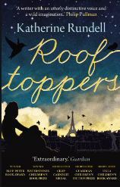  Rooftoppers  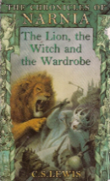  The Lion the Witch and the Wardrobe  (The Chronicles of Narnia)
Writing Focus | Recount  Adventure Narrative  Persuasive writing |  | Non-chronological report  Balanced argument  Diary entry |  |  | Newspaper report  Poetry
Year 6 | 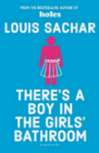  There’s a Boy in the  Girls’ Bathroom  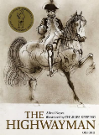  The Highwayman | 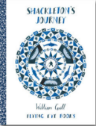  Shackleton’s Journey  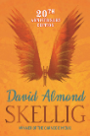  Skellig | Wonder  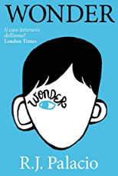 |  | Rose Blanche  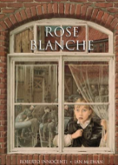 | 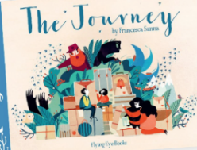  The Journey | Macbeth  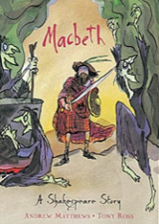
Writing Focus | Informal letter  Diary Entry  Play script  Narrative | Formal letter  Poetry  Newspaper article  Narrative  Character Description | Non-chronological report  Scripts  Diary Entry  Debate/balanced argument |  | Diary Entry  Letter writing  Journal writing | Poetry  Persuasive letter  Narrative  Emotive letter | Formal letter  Written and performance poetry  Play scripts  Reviews

